# Please follow step 1 thru 4 to see what the problem is.

Start-Situation:

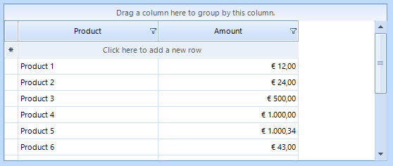

# Step 1:

Set filter on Product (select 3 records)

# Step 2:

Select only one Amount

You only see 3 values instead of all values available but thats because there is allready a filter on Product, so this is correct.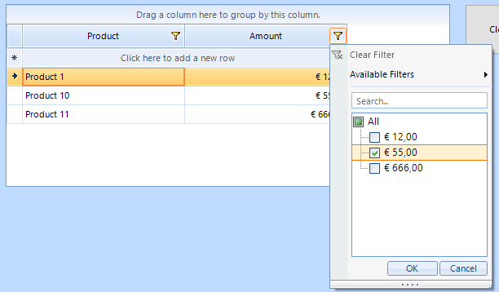

# Step 3:

Press button ‘Clear Filter’

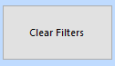

The code behind this button is:

private void button1_Click(object sender, EventArgs e)

{

radGridView1.FilterDescriptors.Clear();

}

# Step 4: The Problem!

All filters should be removed, and reset, but that seems not to be the case!

See for yourself when trying to put a filter on Amount:

Now you SHOULD see all 12 different amounts but you still see only 3.

It looks like as the previously putted filter on Product (see step 1) is somehow still active.

